EARB

Past Decisions

<https://wiki.gccollab.ca/GC_Enterprise_Architecture/Board/Past_Sessions>

January 17th 2020 - [Drupal Reference Architecture](https://gcconnex.gc.ca/file/view/59227335/gc-earb-2020-01-17-03-stats-canada-drupal-reference-cloud-architecture-pptx?language=en) (TBS & Stats)

Case Management – EARB – [GC EARB Files](https://gccollab.ca/file/group/154708/all)

| **August 22, 2019 - FULL** | |
| --- | --- |
|  | |
| **GC Case - Status Update and Roadmap** PSPC | |
| **May 2, 2019 - FULL** | |
|  | |
| Tobacco - Case Mgt. Approach - HC | | | HC |
| **March 7, 2019** | | |
|  | | |
| Case Management Modernization - CHRC | | | CHRC |

ESDC

Business Capability Model -> Value Streams mapping (not to be confused with LEAN Value Stream Mapping)

Business -> Applications

Enterprise Reference Data Model

<https://gcconnex.gc.ca/discussion/view/84658177/mapping-business-capabilities-to-applications?language=en> (from EARB Ref.Data.Model WG - <https://gcconnex.gc.ca/file/view/83638189/reference-data-to-support-enterprise-data-reference-model-2021-07-14?language=en>

- from Data Arch WG ([Enterprise Reference Data Model](https://gcconnex.gc.ca/file/view/73795203/enterprise-data-reference-model-iteration-2-address?language=en))

# GC Cloud Native Platform

[Cloud Native Platform (govcloud.ca)](https://govcloud.ca/)

[GitHub - StatCan/cloud-native-platform: User guide for the Cloud Native Platform for Government](https://github.com/statcan/cloud-native-platform)

Website - [GitHub - google/docsy: A set of Hugo doc templates for launching open source content.](https://github.com/google/docsy)

The cloud native platform for government is built on top of open source Kubernetes primarily leveraging projects from the Cloud Native Computing Foundation (CNCF). Built from experience running as close as possible to open source Kubernetes while codifying the best practices shared by successful real-world implementations. This can be seen as a reference architecture where we strive to solve the difficult parts of deploying and managing cloud native services for government.

GovCloud.ca – seems based on [Hugo (SSG)](https://gohugo.io/)

[Government of Canada Enterprise Architecture Review Board | Cloud Native Platform (govcloud.ca)](https://govcloud.ca/blog/2020/01/17/government-of-canada-enterprise-architecture-review-board/)

<https://govcloud.blob.core.windows.net/docs/architecture.pdf>

# Cloud Native Team – to GC EARB - [Government of Canada Enterprise Architecture Review Board | Cloud Native Platform (govcloud.ca)](https://govcloud.ca/blog/2020/01/17/government-of-canada-enterprise-architecture-review-board/)

<https://govcloud.blob.core.windows.net/docs/architecture-links.txt>

[aks]: https://github.com/canada-ca-terraform-modules/terraform-kubernetes-aks

[aks-platform]: https://github.com/canada-ca-terraform-modules/terraform-kubernetes-aks-platform

[azure-files]: https://docs.microsoft.com/en-us/azure/aks/azure-files-dynamic-pv

[cncf]: https://www.cncf.io

[devsecops]: https://software.af.mil/dsop/documents/

[docker]: https://hub.docker.com/r/drupalwxt/site-wxt

[drupal]: https://github.com/drupalwxt/wxt

[iks]: https://github.com/canada-ca-terraform-modules/terraform-kubernetes-iks

[iks-platform]: https://github.com/canada-ca-terraform-modules/terraform-kubernetes-iks-platform

[jfrog-artifactory]: https://jfrog.com/artifactory

[jfrog-xray]: https://jfrog.com/xray

[govcloud]: https://govcloud.ca

[istio]: https://istio.io/docs/tasks/traffic-management/ingress/ingress-control

[helm-drupal]: https://github.com/drupalwxt/helm-drupal

[kubernetes]: https://kubernetes.io

[minio]: https://www.minio.io

[mysql]: https://www.mysql.com

[nginx]: https://www.nginx.com

[php-fpm]: https://php-fpm.org

[postgresql]: https://www.postgresql.org

[s3fs]: https://www.drupal.org/project/s3fs

[site-wxt]: https://github.com/drupalwxt/site-wxt

[travis-wxt]: https://travis-ci.org/drupalwxt/wxt

[travis-site-wxt]: https://travis-ci.org/drupalwxt/site-wxt

[wxt]: https://github.com/drupalwxt/wxt

[youtube-digican]: https://www.youtube.com/watch?v=QvMWls8OdmM

[playground (windows.net)](https://govcloud.blob.core.windows.net/docs/azure-aks-platform.pdf)

William Hearn - <https://github.com/sylus>

# USA DoD – DevSecOps

[Documents | Office of the Chief Software Officer, U.S Air Force (af.mil)](https://software.af.mil/dsop/documents/)

## KuberNetes Distro Picker

[kubernetes-readiness-dod.md · master · DSAWG DevSecOps / Team 2 Kubernetes STIG / k8-SRG-Artifacts · GitLab (dso.mil)](https://repo1.dso.mil/dsawg-devsecops/kubernetes-srg/k8-srg-artifacts/-/blob/master/kubernetes-readiness-dod.md)

builds docs - [build · master · DSAWG DevSecOps / Team 1: DoD Enterprise DevSecOps Ref Design` / Team1_Artifacts · GitLab (dso.mil)](https://repo1.dso.mil/dsawg-devsecops/dod-enterprise-devsecops-ref-design/team1_artifacts/-/tree/master/build)

## DevSecOps Team 1 – Ref Arch – body.md

[build/body.md · master · DSAWG DevSecOps / Team 1: DoD Enterprise DevSecOps Ref Design` / Team1_Artifacts · GitLab (dso.mil)](https://repo1.dso.mil/dsawg-devsecops/dod-enterprise-devsecops-ref-design/team1_artifacts/-/blob/master/build/body.md)

(uses pandoc - [build/convert.sh · master · DSAWG DevSecOps / Team 1: DoD Enterprise DevSecOps Ref Design` / Team1_Artifacts · GitLab (dso.mil)](https://repo1.dso.mil/dsawg-devsecops/dod-enterprise-devsecops-ref-design/team1_artifacts/-/blob/master/build/convert.sh) )

## GitLab EE - [Help · GitLab (dso.mil)](https://repo1.dso.mil/help)

GitLab is open source software to collaborate on code.  
Manage git repositories with fine-grained access controls that keep your code secure.  
Perform code reviews and enhance collaboration with merge requests.  
Each project can also have an issue tracker and a wiki.  
Used by more than 100,000 organizations, GitLab is the most popular solution to manage git repositories on-premises.  
Read more about GitLab at [about.gitlab.com](https://about.gitlab.com/).

* [Index · User · Help · GitLab (dso.mil)](https://repo1.dso.mil/help/user/index.md)
* Trends in Version Control – Microservices - [Trends in Version Control Land: Microservices | GitLab](https://about.gitlab.com/blog/2016/08/16/trends-in-version-control-land-microservices/)
* Trends in Innersource - [Index · User · Help · GitLab (dso.mil)](https://repo1.dso.mil/help/user/index.md)

Case Management

PHAC / HC – Low Code PBMS (Appian) - [61373283 (gcconnex.gc.ca)](https://gcconnex.gc.ca/file/download/61373283)

Data Governance – Province Territory - [61354081 (gcconnex.gc.ca)](https://gcconnex.gc.ca/file/download/61354081)

GCCase 2020 Symposium [PowerPoint Presentation (gcconnex.gc.ca)](https://gcconnex.gc.ca/file/download/69232529/)

GCCase 2020 – DG Operatiosn [PowerPoint Presentation (gcconnex.gc.ca)](https://gcconnex.gc.ca/file/download/59459889/)

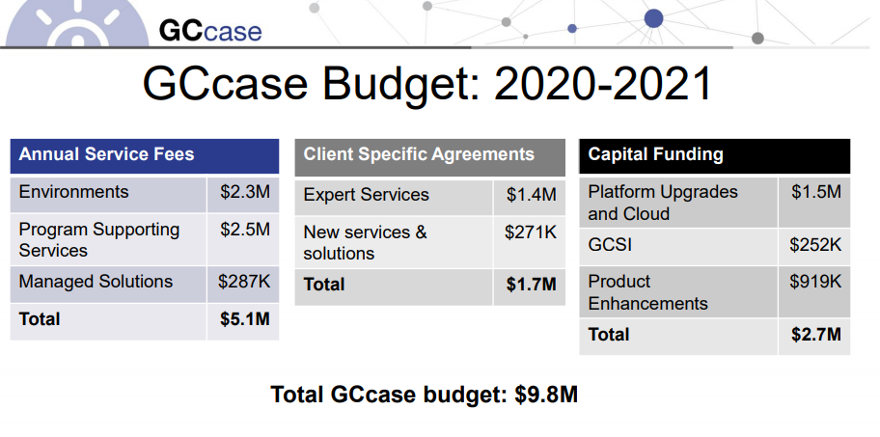

Key takeaways:

• Most organizations are focused on cloud;

• Still many unknowns with regards to costing, timing, dependencies, etc.

• Identified need to maintain private cloud environments, as many plan to have hybrid deployments

• Significant interest in

⎫Common solutions, i.e. HR, personnel security

⎫Integration with My GCHR

⎫Proxy service